- Praktikum 2.1 a. Listing

#include <stdio.h>
#include <stdlib.h>

typedef struct simpul Node;

struct simpul{
int data;
Node *next;

};
Node *head=NULL, *p, *bef, *pbef;

void awal();
void akhir();

void stelah();
void sbelum();
void alokasi();
void tampil();

int main()
{
int menu;

printf("=====MENU=====\n");

printf("1. Awal\n");
printf("2. Akhir\n");
printf("3. After\n");
printf("4. Before\n");
printf("5. Keluar\n");

printf("pilih menu: ");

scanf("%d",&menu);

do{

char jwb;
switch(menu){
case 1:
puts("\nInsert Awal");
do{

fflush(stdin);
alokasi();
awal();
fflush(stdin);
printf("Lagi (y/t)? ");

jwb=getchar();
}while((jwb=='y')||(jwb=='Y'));
puts("");
tampil();
break;

case 2 :
puts("\nInsert Akhir");
do{
fflush(stdin);
alokasi();

akhir();
fflush(stdin);
printf("Lagi (y/t)? ");

jwb=getchar();
}while((jwb=='y')||(jwb=='Y'));
puts("");
tampil();
break;

case 3 :
puts("\nInsert After");
if(head==NULL){

printf("SLL masih kosong");
break;
}else{
alokasi();
stelah();
tampil();
break;

}
case 4 :
puts("\nInsert Before");
if(head==NULL){

printf("SLL masih kosong");

break;
}else{
alokasi();
sbelum();
tampil();

break;
}
default:
exit(0);
break;

}
printf("\n=====MENU=====\n");
printf("1. Awal\n");
printf("2. Akhir\n");
printf("3. After\n");

printf("4. Before\n");
printf("5. Keluar\n");
printf("pilih menu: ");
scanf("%d",&menu);
}while(menu!=5);

}
void tampil(){
Node *baca;
baca=head;
printf("isi dari SLL\n");

while(baca!=NULL){
printf("%d\n",baca->data);
baca=baca->next;
}
}

void alokasi(){
int x;
printf("\nData yg mau disimpan: ");
scanf("%d",&x);
p=(Node *) malloc(sizeof(Node));
if(p==NULL){
puts("gagal");

exit(0);
}else{
p->data=x;
p->next=NULL;
}

}
void awal(){
if(head!=NULL)
p->next=head;
head=p;

}
void akhir(){
Node *tail;

if(head==NULL)

head=p;
else{
tail=head;
while(tail->next!=NULL)
tail=tail->next;

tail->next=p;
tail=tail->next;
}
}
void stelah(){

Node *after;
int key;

printf("Disisipkan setelah node berapa ? ");
scanf("%d",&key);
after=head;

while(after->data!=key){
if(after->next==NULL){
printf("%d ga ada dlm SLL\n", key);
exit(0);
}else{

after=after->next;
}
}
p->next=after->next;
after->next=p;

}
void sbelum(){
Node *bef, *pbef;
int key;

printf("Disisipkan sebelum node berapa? ");
scanf("%d", &key);
bef=head;
while(bef->data!=key){
if(bef->next==NULL){

printf("%d tdk ada dlm SLL\n",key);
exit(0);
}else{
pbef=bef;
bef=bef->next;
}
}

p->next=bef;

pbef->next=p;

}

b. Output
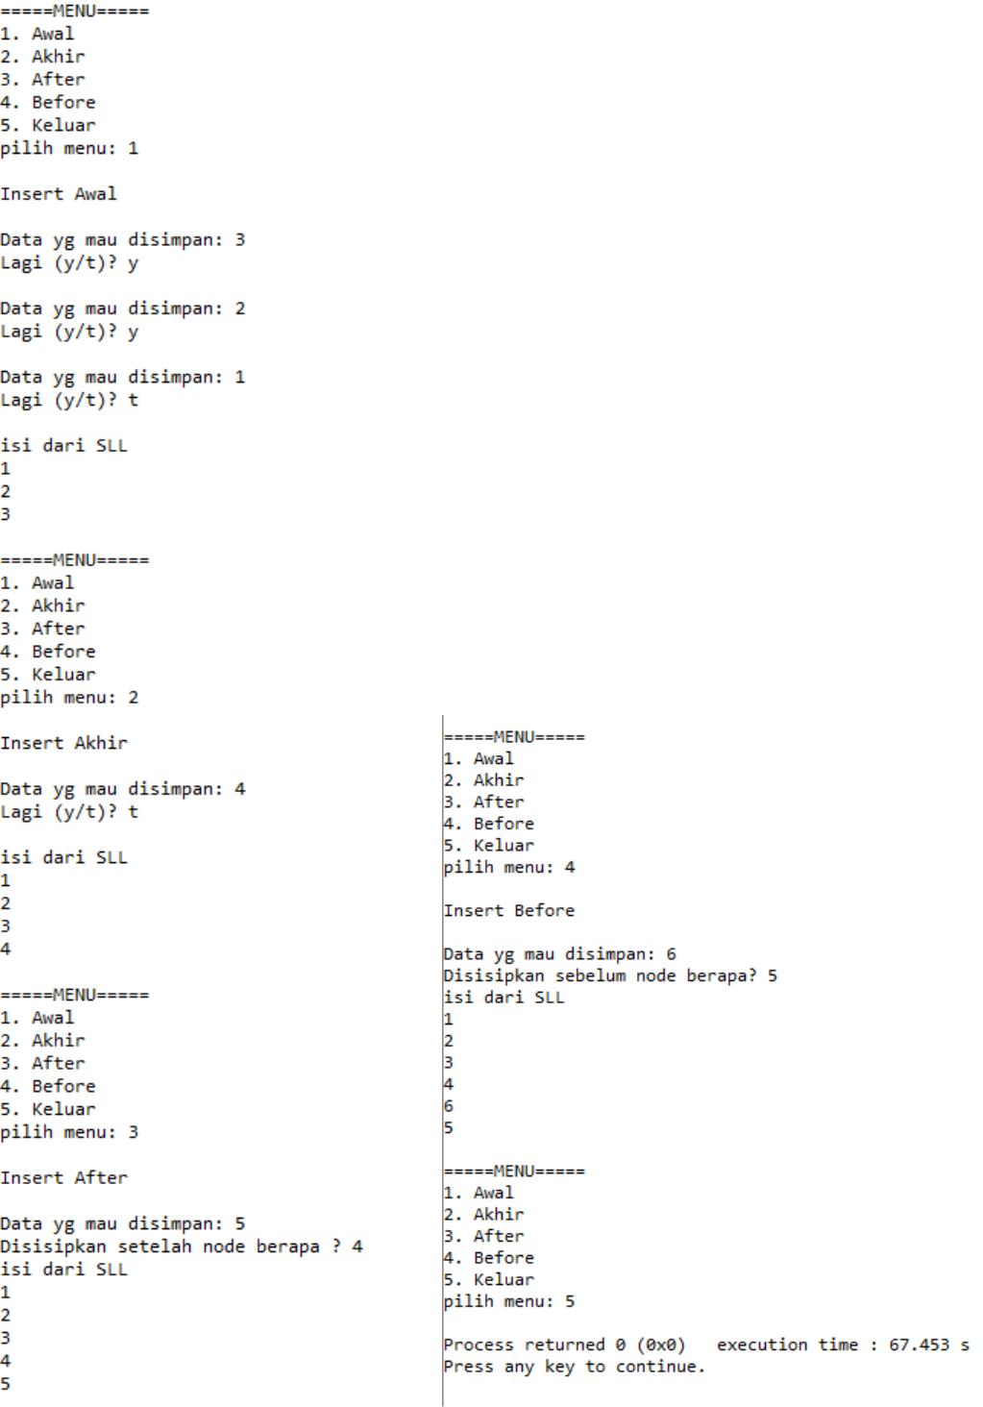

- Praktikum 2.2 a. Listing

#include <stdio.h>
#include <stdlib.h>

typedef struct siswa Node;

struct siswa{
int no;
char nama[20];

float nilai;
Node *next;
};
Node *head=NULL, *p, *bef, *pbef;

void awal();
void akhir();
void stelah();
void sbelum();
void alokasi();

void tampil();

int main()
{
int menu;

printf("=====MENU=====\n");

printf("1. Awal\n");
printf("2. Akhir\n");
printf("3. After\n");

printf("4. Before\n");
printf("5. Keluar\n");

printf("pilih menu: ");
scanf("%d",&menu);

do{

char jwb,tmbh_data,key;
switch(menu){
case 1:

do{
fflush(stdin);
alokasi();
awal();
fflush(stdin);

printf("Lagi (y/t)? ");
jwb=getchar();
}while((jwb=='y')||(jwb=='Y'));
puts("");
tampil();

break;
case 2 :
do{
fflush(stdin);
alokasi();

akhir();
fflush(stdin);
printf("Lagi (y/t)? ");

jwb=getchar();
}while((jwb=='y')||(jwb=='Y'));
puts("");
tampil();
break;

case 3 :
if(head==NULL){
printf("SLL masih kosong");
break;
}else{

fflush(stdin);
printf("Ingin memasukkan data setelah data ttt
(y/t)? ");
scanf("%c",&tmbh_data);
if(tmbh_data=='y'||tmbh_data=='Y'){

alokasi();
stelah();
}
tampil();
break;

}
case 4 :
if(head==NULL){
printf("SLL masih kosong");
break;

}else{
fflush(stdin);
printf("Ingin memasukkan data setelah data ttt
(y/t)? ");
scanf("%c",&tmbh_data);

if(tmbh_data=='y'||tmbh_data=='Y'){ printf("Disisipkan sebelum nomor berapa? "); scanf("%d", &key);
alokasi();
sbelum(key);
}
tampil();
break;
}
default:

exit(0);
break;
}
printf("\n=====MENU=====\n");
printf("1. Awal\n");

printf("2. Akhir\n");
printf("3. After\n");
printf("4. Before\n");
printf("5. Keluar\n");
printf("pilih menu: ");

scanf("%d",&menu);
}while(menu!=5);
}
void tampil(){
Node *baca;
baca=head;

printf("data yang telah diinputkan: \n"); printf("\nNo\tNama\tNilai\n"); while(baca!=NULL){

printf("%d\t%s\t%g\n", baca->no, baca->nama, baca->nilai); baca=baca->next;
}

}
void alokasi(){
int no;
char nama[20];
float nilai;

printf("\nNo: ");
scanf("%d",&no);
fflush(stdin);
printf("Nama: ");
scanf("%s",&nama);

fflush(stdin);
printf("Nilai: ");
scanf("%g",&nilai);
p=(Node *) malloc(sizeof(Node));
if(p==NULL){

puts("gagal");
exit(0);
}else{
p->no=no;
strcpy(p->nama, nama);

p->nilai=nilai;
p->next=NULL;
}
}
void awal(){

if(head!=NULL)
p->next=head;
head=p;
}
void akhir(){

Node *tail;

if(head==NULL)
head=p;
else{

tail=head;
while(tail->next!=NULL)
tail=tail->next;
tail->next=p;
tail=tail->next;

}
}
void stelah(){
Node *after;
int key;

printf("Disisipkan setelah nomor berapa ? ");
scanf("%d",&key);
after=head;
while(after->no!=key){
if(after->next==NULL){
printf("%d ga ada dlm SLL\n", key);
exit(0);

}else{
after=after->next;
}
}
p->next=after->next;

after->next=p;
}
void sbelum(){
Node *bef, *pbef;
int key;

printf("Disisipkan sebelum nomor berapa? ");

scanf("%d", &key);
bef=head;
while(bef->no!=key){

if(bef->next==NULL){
printf("%d tdk ada dlm SLL\n",key);
exit(0);
}else{
pbef=bef;

bef=bef->next;
}
}
p->next=bef;
pbef->next=p;

}
b. Output
